2APHY Nuclear Physics Assignment One 2009

Name: _________________________________________________ (50 marks total)
- Complete the following. (3 marks)
Element | Nuclide | Atomic Number | Number Of Neutrons | Mass Number
Nitrogen-14 | 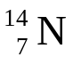 | 7 | 7 | 14
Nitrogen-13 | 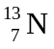 | 7 | 6 | 13
Carbon-14 | 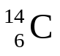 | 6 | 8 | 14
Helium-4 | 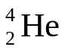 | 2 | 2 | 4

- Two of the elements above are isotopes of each other. Which are they and why are they isotopes?
Nitrogen-13 and Nitrogen-14
They are isotopes because they are the same element (same atomic number, number of protons) but have different mass numbers (number of neutrons).
______________________________________________________________________ (2 marks)
- In a lab report on a Nuclear Physics experiment, a student summarized some information on radiation. The table below shows part of his report. Complete the table to include all the information. (3 marks)

What it is | Radiation symbol | Name of radiation | Transmutation ability (yes or no) | Stopped by
Like a Helium nucleus | α | Alpha | Yes | 10 cm of air
High speed electron | β | Beta | Yes | Thin metal sheet  e.g. Al
Electromagnetic radiation | γ | Gamma | no | Thick lead or concrete

- Complete the following equations and name the radiation or particle produced.
a. 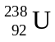 → 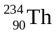 + 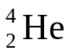 alpha (1 mark)
b. 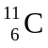 → 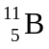 + 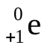 positron 1 mark)
c. 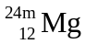→ 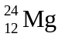 + 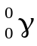 gamma 1 mark)
d. Calcium-45 decays emitting a beta particle and a new element is formed. (3 marks)
  - Write the full nuclear equation.
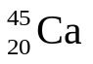 → 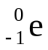 + 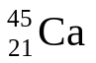
  - What is the atomic number of the new element? 21
  - What is the mass number of the new element? 45
- Explain, using your understanding of the structure of alpha, beta and gamma radiation, why alpha particles can’t penetrate the skin, beta can penetrate to about 2.0 cm and gamma can go straight through the body. (3 marks)

Alpha: Alpha radiation is a particle composed of two protons and two neutrons and is like a helium atom. It has a large mass and is slow moving so is easily stopped by the skin.

Beta: Is a high speed electron from the nucleus of the atom. It is very small and moves close to the speed of light. Due to its size and speed it can penetrate into the body but as it is a particle it is stopped by the body’s tissues.

Gamma: Gamma radiation is an electromagnetic radiation so is not a particle. It has no mass and travels at the speed of light. As it is energy and has no mass, it can travel straight through the body.

- People who work in mines, especially those that may contain small amounts of radon gas, are strongly advised not to smoke as well as this increases their chance of getting cancer. Explain why breathing in radon gas (which is an alpha emitter) can cause cancer. (2 marks)

If you breathe in radon gas, it will start emitting alpha particles in your lungs. Due to their size, Alpha particles are high ionizing particles and cause molecules in your body (particularly water) to break into ions when the alpha particle hits them. Ions in the body are highly reactive and can cause unwanted chemical reactions that can cause cancer.

- Within a Nuclear Power Plant, some research scientists were studying the half-life of Polonium. The activity of a particular sample of polonium was 8.4 x 10³ Bq. They knew that the half-life of polonium was 140 days and wanted to know how long it would take for the sample to reach an activity of 525 Bq. Using your understanding of half-life, calculate this time for them. (2 marks)

A₀ = 8.40 x 10³ Bq 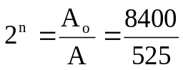
A = 525 Bq 2^{n} = 16
Half-life = 140 days n = 4

Total time = n x half-life
= 4 x 140
= 560 days

Total time = 560 days (2sf)

- University students, studying the activity of a particular radioactive isotope which had a half-life of 12.0 hours. If the original activity of the sample was 448 kBq, what would the activity be 3.00 days later? (2 marks)

A₀ = 448 kBq 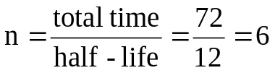
A = ?
Half-life = 12 hours A = A₀ (0.5)^{n}
Total time = 3 x 24 A = 448 x (0.5)⁶
= 72 hours A = 448 x 0.015625

A = 7.00 kBq (3sf)

- An industrial worker accidentally inhaled a radioisotope with an activity of 0.200 kBq. The substance swallowed has a very long effective half-life and therefore the activity will not change significantly during the worker’s lifetime. Every decay of the isotope releases 1.12 x 10⁻¹⁴ J of energy into the body and the radioisotope is not eliminated from the body. Determine the amount of energy absorbed in one year by the worker from this substance. (1 year = 365 days) (2 marks)

Activity (in Bq) x energy x time in seconds

200 x 1.12 x 10⁻¹⁴ x 365 x 24 x 60 x 60

Energy absorbed = 7.06 x 10⁻⁵ J (3sf)

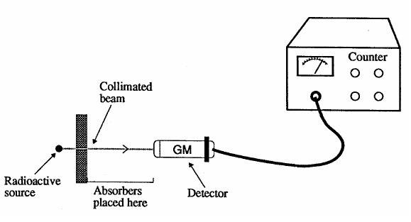
- Students were given a radioactive source which emitted either alpha, beta or gamma radiation. They were instructed to identify the types of radiation emitted by the source. The experimental arrangement is illustrated.

Their results were:
Material between source and counter | Counts per minute
10 mm air | 3549
Sheet of paper | 2613
2 mm of aluminium | 156
5 cm lead | 8

What type of radiation was emitted from the source? ____beta radiation_______ (1 mark)

- Some radioisotopes have a short half life such as Sodium-24 (Na-24) which has a half-life of 15 hours. Sodium-24 is a beta emitter with a high activity and is used as a tracer in blood circulation studies.
- Write the nuclear equation for sodium-24 emitting beta radiation. (1 mark)
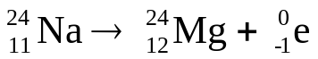
- A medical technician received a 5.0 g sample of sodium-24 but a week later she needed to order a new sample even though the original sample still had a mass of 5.0 g. Explain why. (1 marks)

While the mass remains the same, only a small portion of it is sodium-24. Much of the mass is now stable magnesium-24 which is not radioactive.

- In an experiment, a student collected the following data for the decay of a radioactive isotope. On the graph paper below, plot the graph the student would have correctly plotted and from the graph estimate the half-live of the radioactive isotope:

Count rate (per second)
1005 820 670 555 455 370 300
Time (minutes)
0 1 2 3 4 5 6

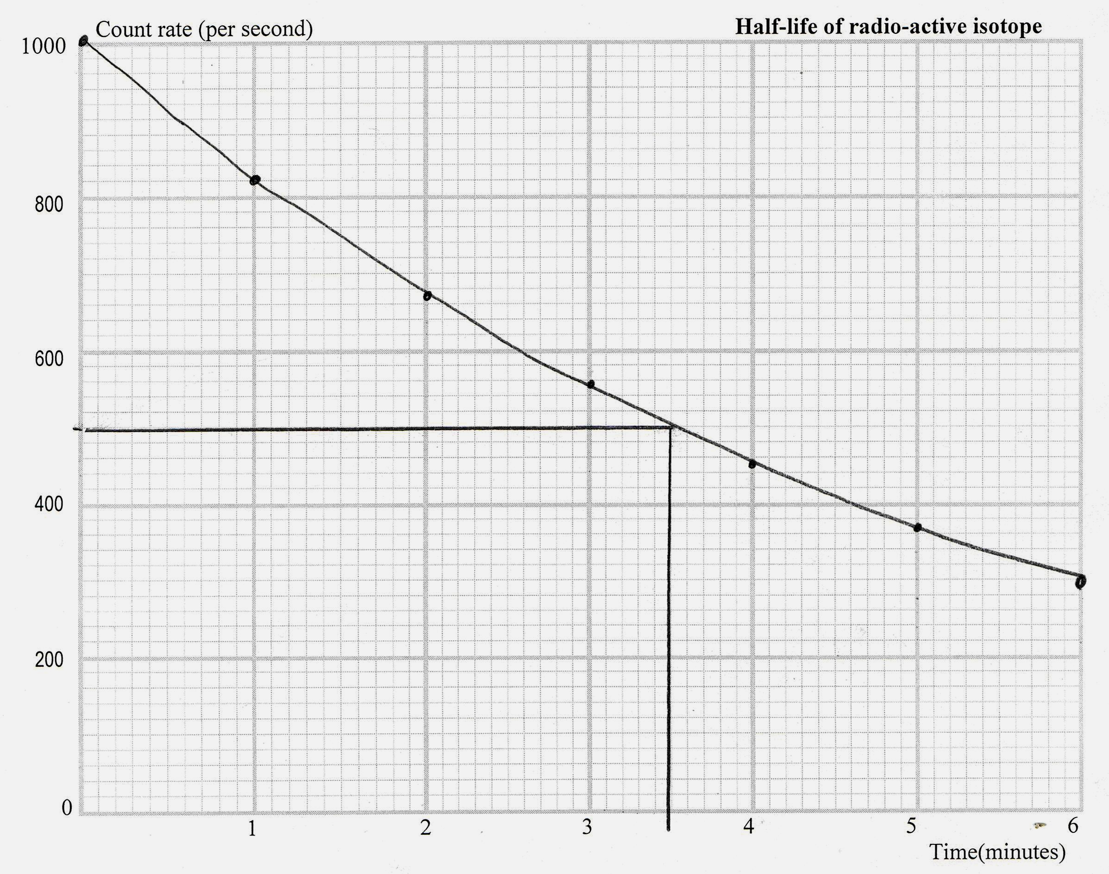

Half-life = __3.5 hours_____ (2 marks)

